Que - power of two using for loop

pow()

{

a=$1

b=$2

c=1

res=1

if((b==0));

then

res=1

fi

if((a==0));

then

res=0

fi

if((a >= 1 && b >= 1));

then

while((c <= b))

do

res=$((res \* a))

c=$((c + 1))

done

fi

echo "$1 to the power $2 is $res"

}

A=2

B=4

pow $A $B

output- 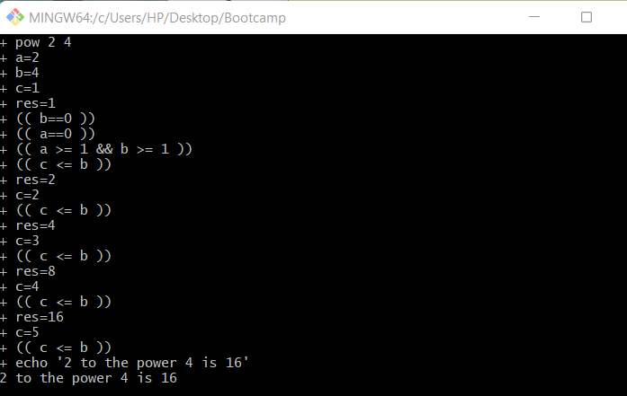

Que- WAP for take input from user determine numbd=er is prime or not.

read -p "Enter num - " num

for((i=2; i<=num/2; i++))

do

if [ $((num%i)) -eq 0 ]

then

echo "$num is not a prime number."

exit

fi

done

echo "$num is a prime number."

Output-

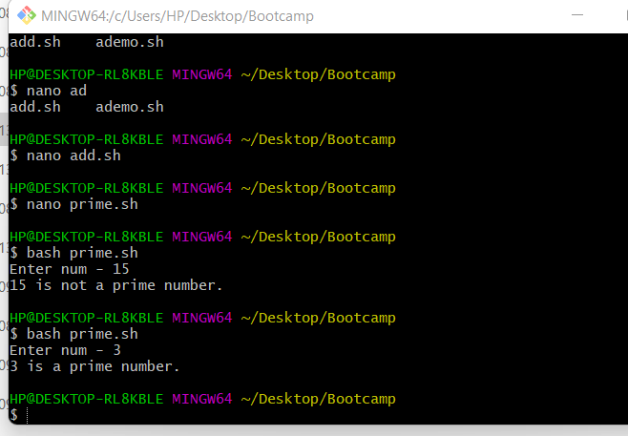

Que- factorial num

echo -n "Enter a number: "

read number

factorial=1

for(( i=1; i<=number; i++ ))

do

factorial=$[ $factorial \* $i ]

done

echo "The factorial of $number is $factorial"

output -

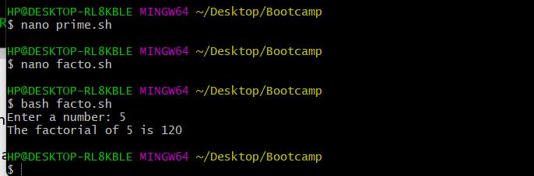

Que-WAP for display prime number between given range

echo enter m and n

read m n

for a in $(seq $m $n)

do

k=0

for i in $(seq 2 $(expr $a - 1))

do

if [ $(expr $a % $i) -eq 0 ]

then

k=1

break

fi

done

if [ $k -eq 0 ]

then

echo $a

fi

done

output-

